Amir Montgomery, Insertion/Bubble Sort Assignment

This assignment was not too bad, I had a bit of trouble with the alternative bubble sort and deciding on how to go forward and backward. I ended up just making a direction bool that swapped after each go through, so it’s not exactly odds = forward, evens = backwards, but it does alternate. I was confused on why results for two different lists came back so similar, but then I noticed it was always either randomized and ascending or randomized and descending – IE, my insertion sort algorithm is really good because the randomized (generated with Fisher-Yates algorithm, source code included) is really close to best case, whereas my bubble sort is terrible because the randomized is close to the worst case.

Alt Bubble Verification

Bubble Verification

Insertion Verification

Insertion Sort

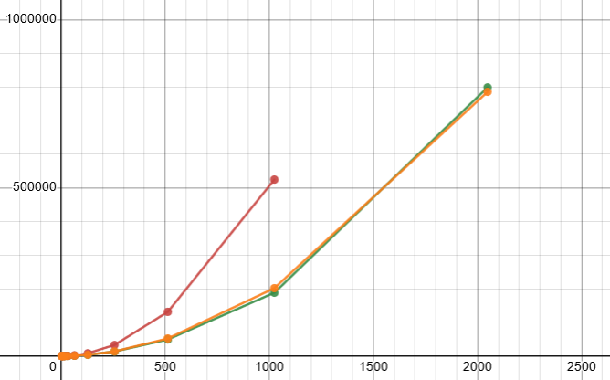

|  |  |  |
| --- | --- | --- |
| Ascending | Descending | Randomized |

Bubble Sort (Descending plot is right under Randomized)

|  |  |  |
| --- | --- | --- |
| Ascending | Descending | Randomized |

Alt. Bubble Sort (Same deal as regular bubble sort)

|  |  |  |
| --- | --- | --- |
| Ascending | Descending | Randomized |